***SMART INTERNZ GUIDED PROJECT***

***Bicycle Sales Analytics using IBM Cognos***

***Name-Sumit Kumar  
Reg No-19BIT0075***

Drive link for the Working Video-

<https://drive.google.com/drive/folders/1HKcR1-tgrf8jcXUeLyqWQdD27hHbEMCN?usp=sharing>

Importing DataSet:  
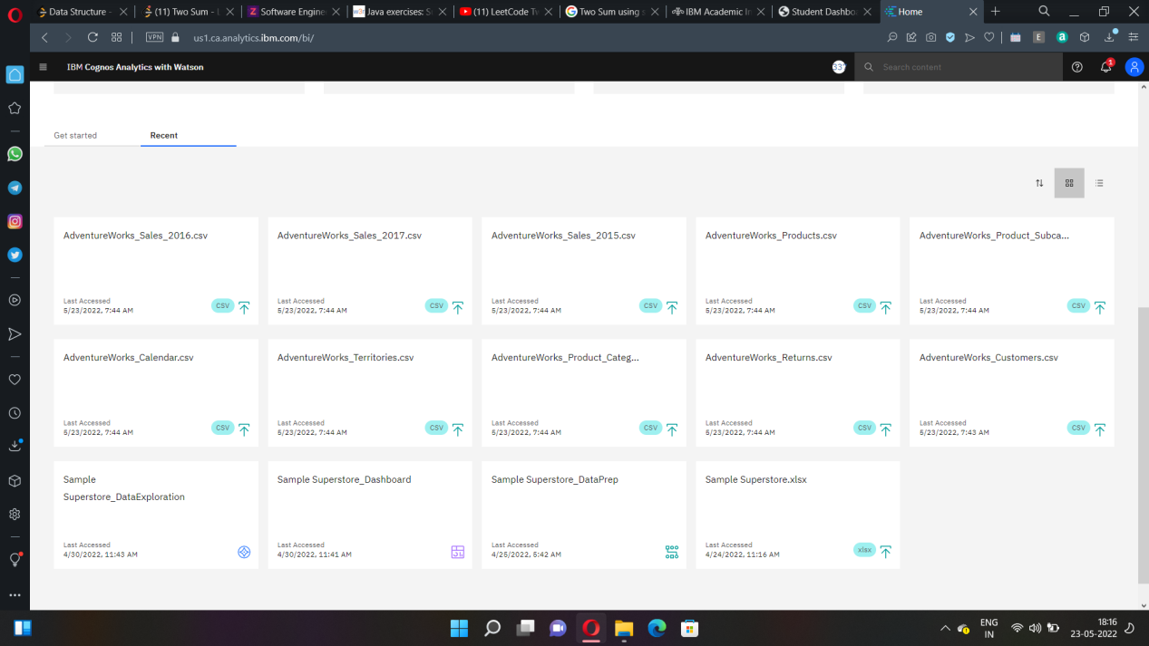

Preparing Data-

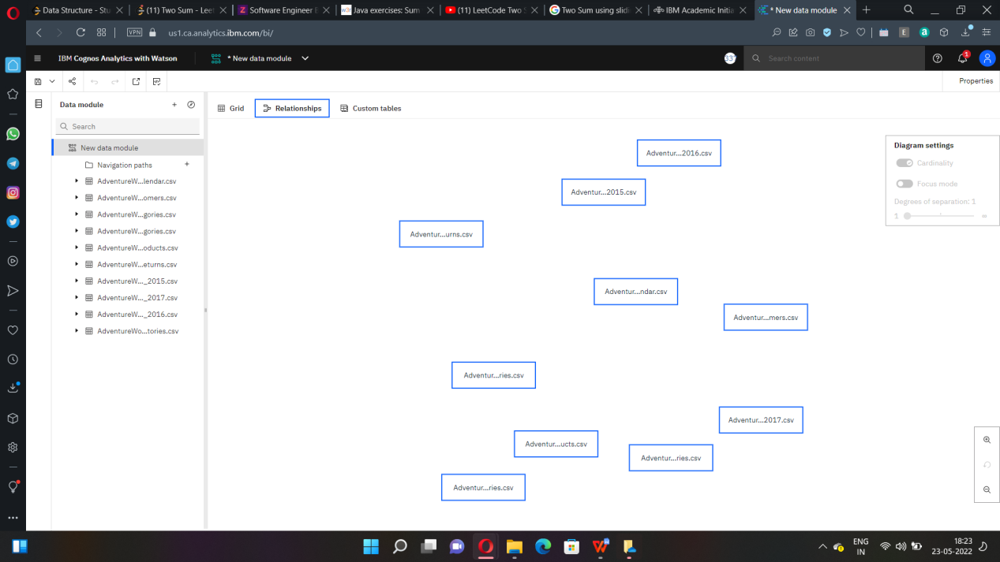

After renaming:

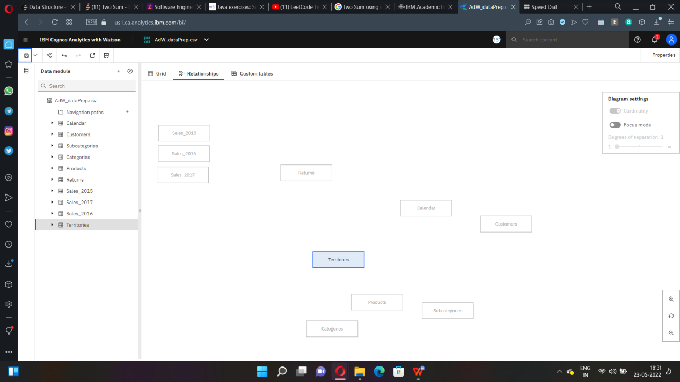

Union of the required Fields-

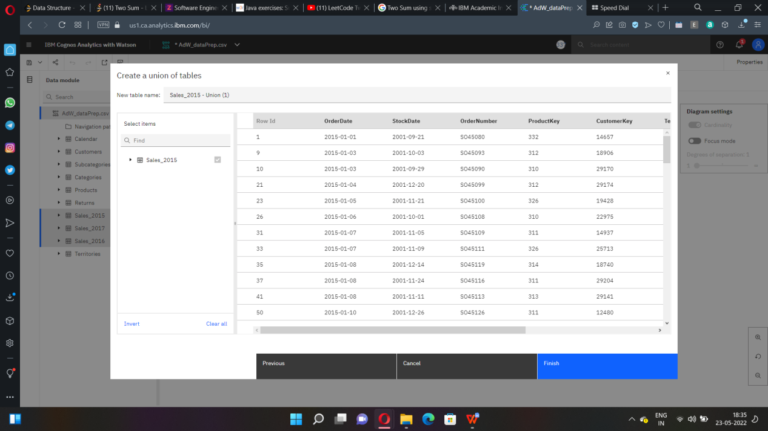

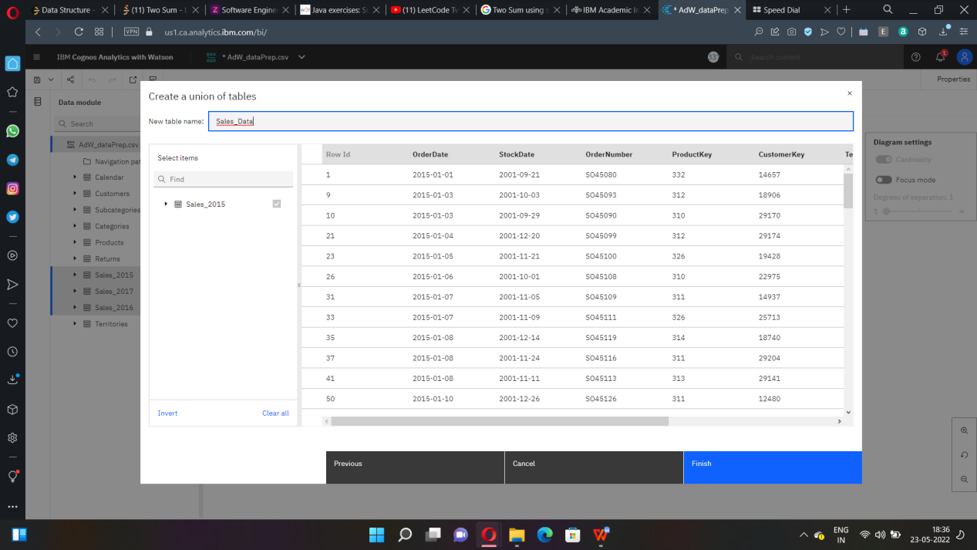

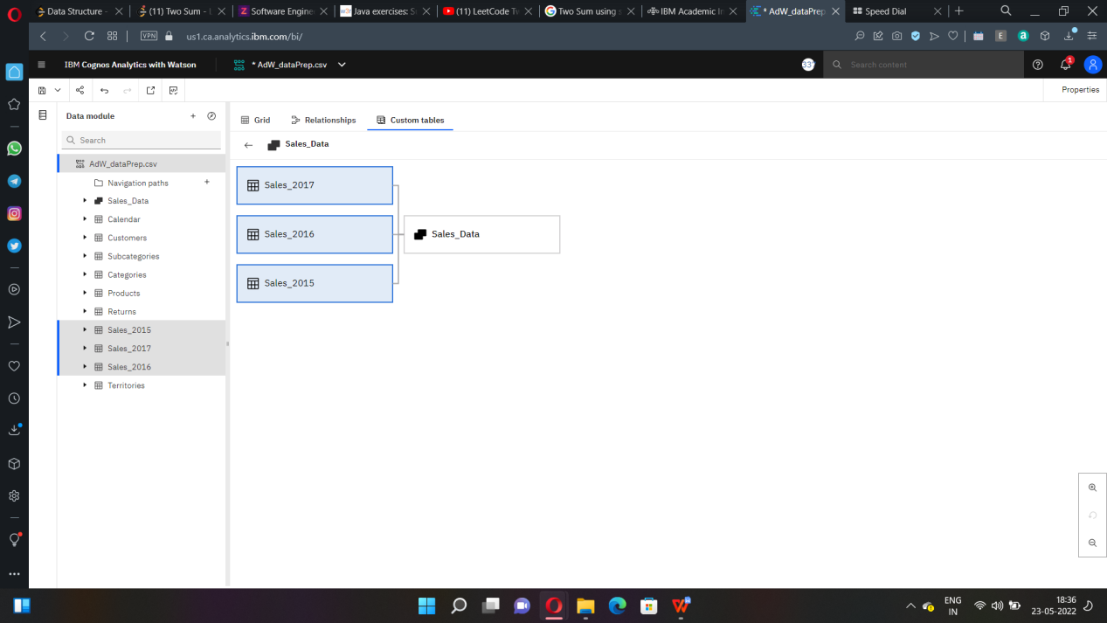

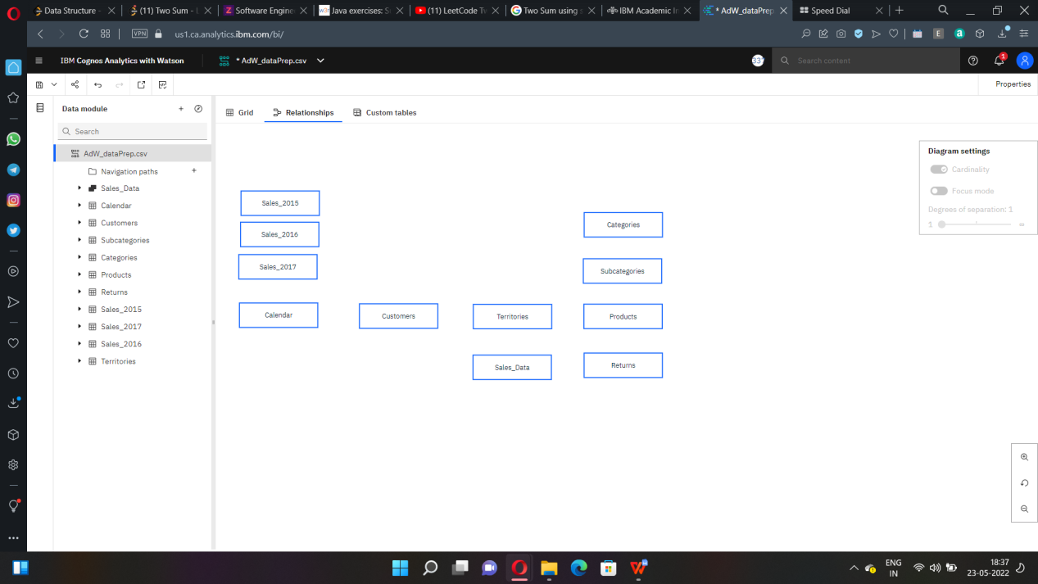

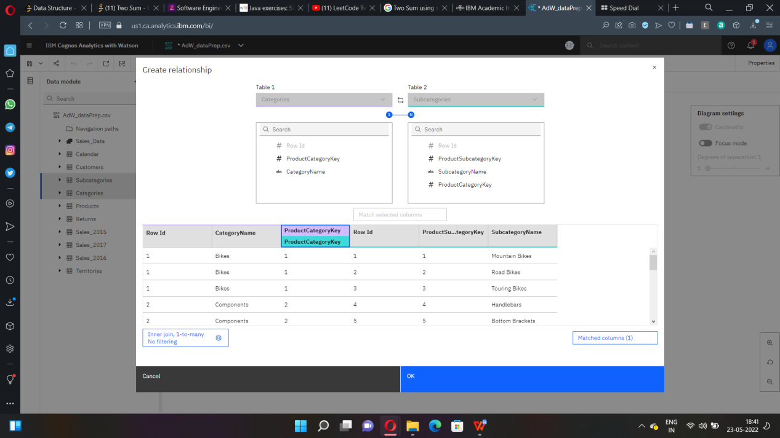

Subcategory and products join:

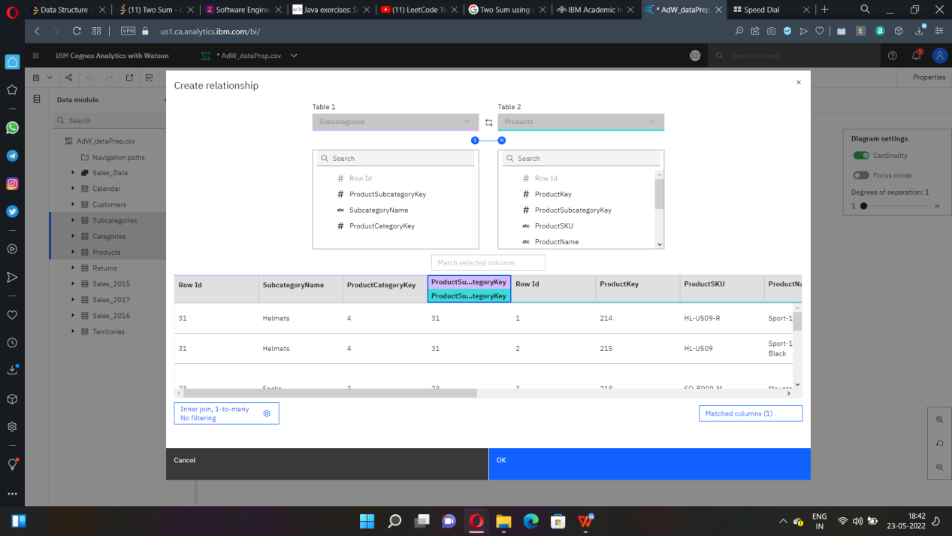

Product and sales data join:

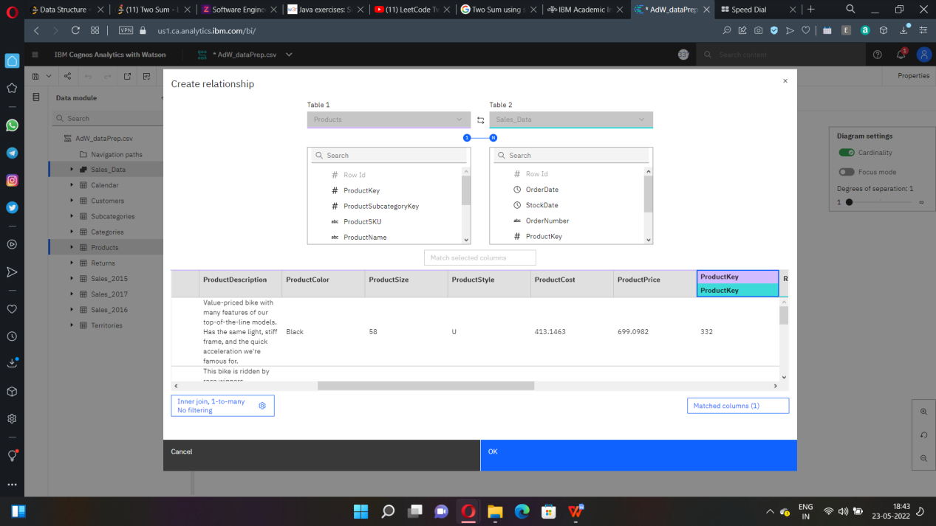

Products and returns join-

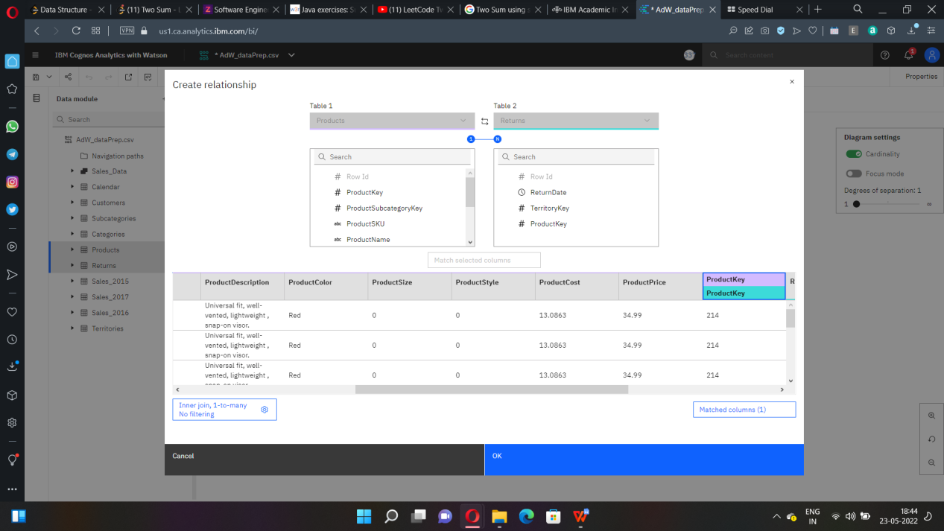

Customer and sales join-

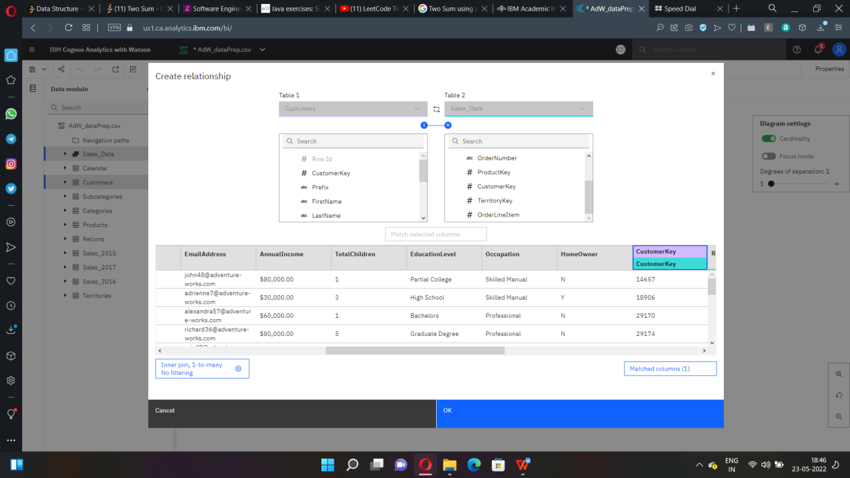

Territory and sales data join-

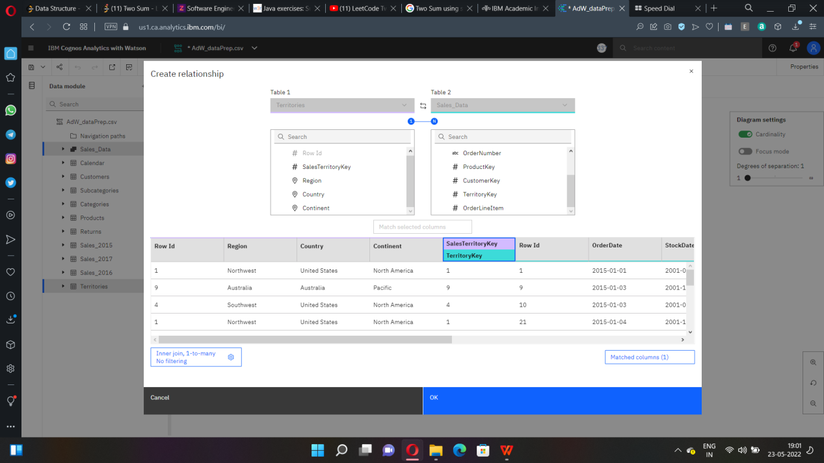

Calendar and Returns join-

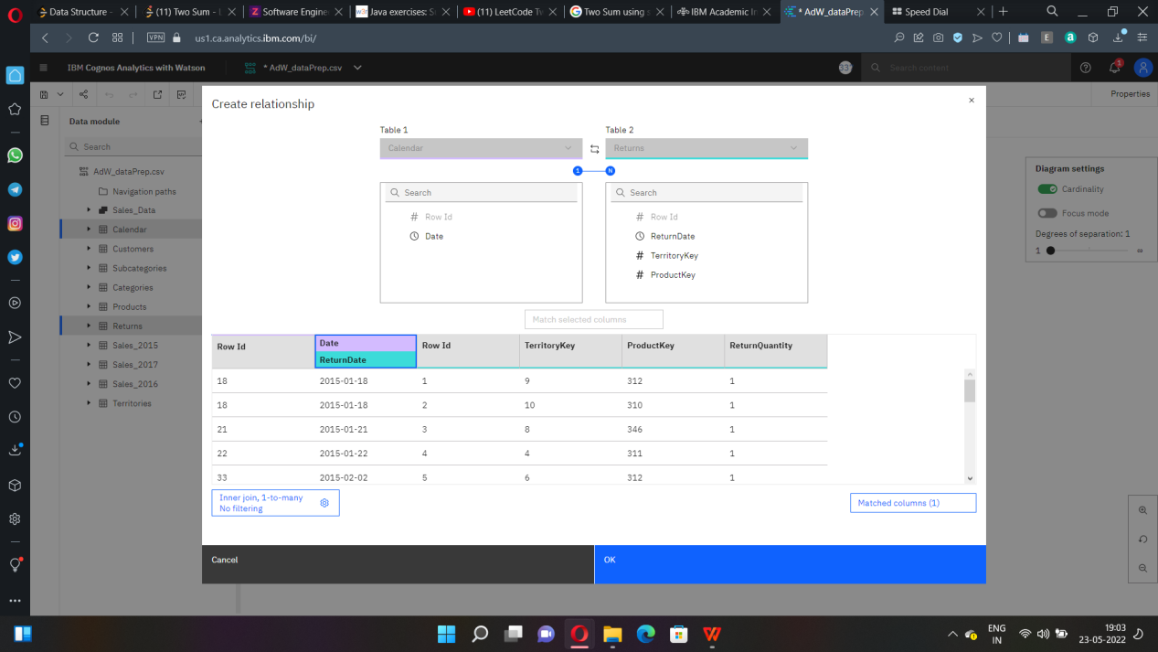

Figure till now after applying joins-

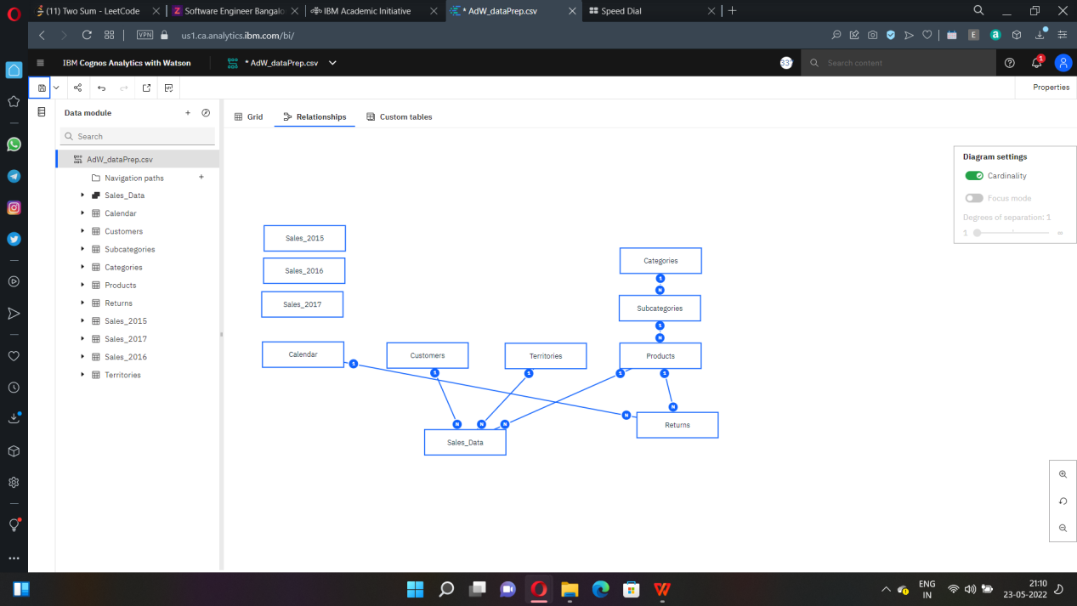

CREATING CALCULATIONS AS FOLLOWS:

Year calculation:

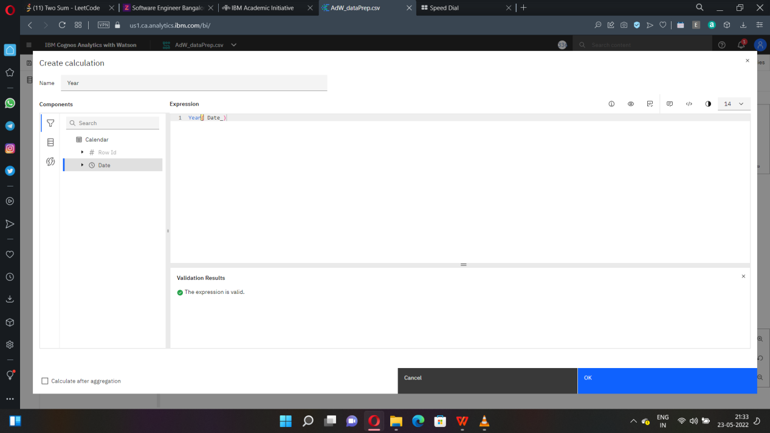

Month Calculation:

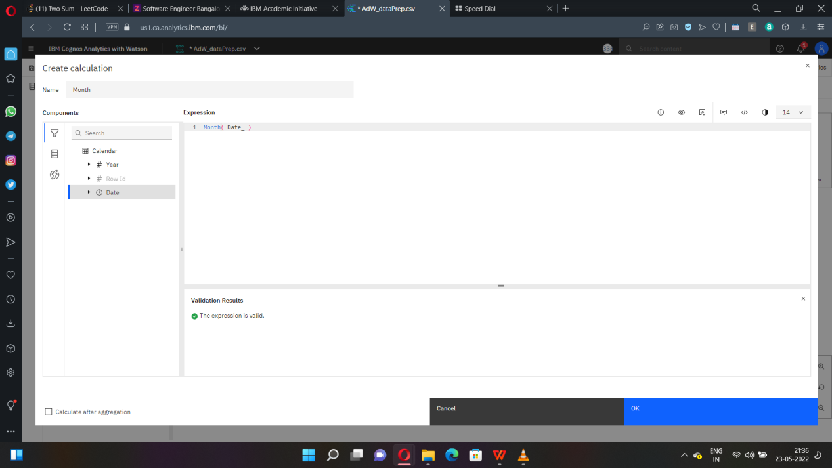

Day Calculation:

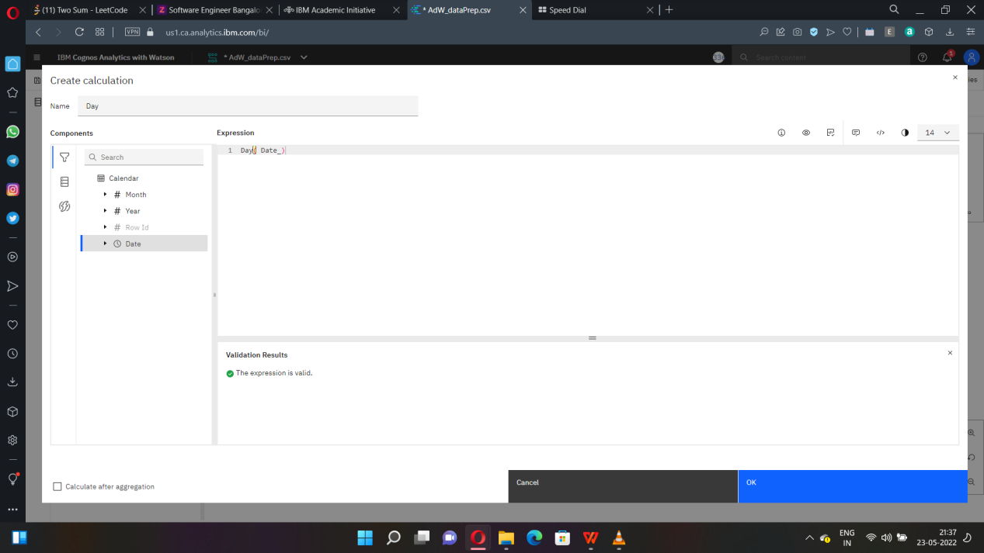

Navigation Path as follows:

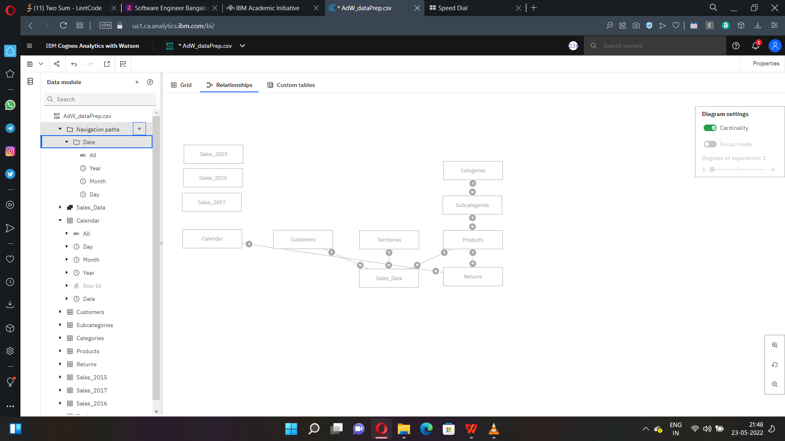



Creating Calculation for return rate:

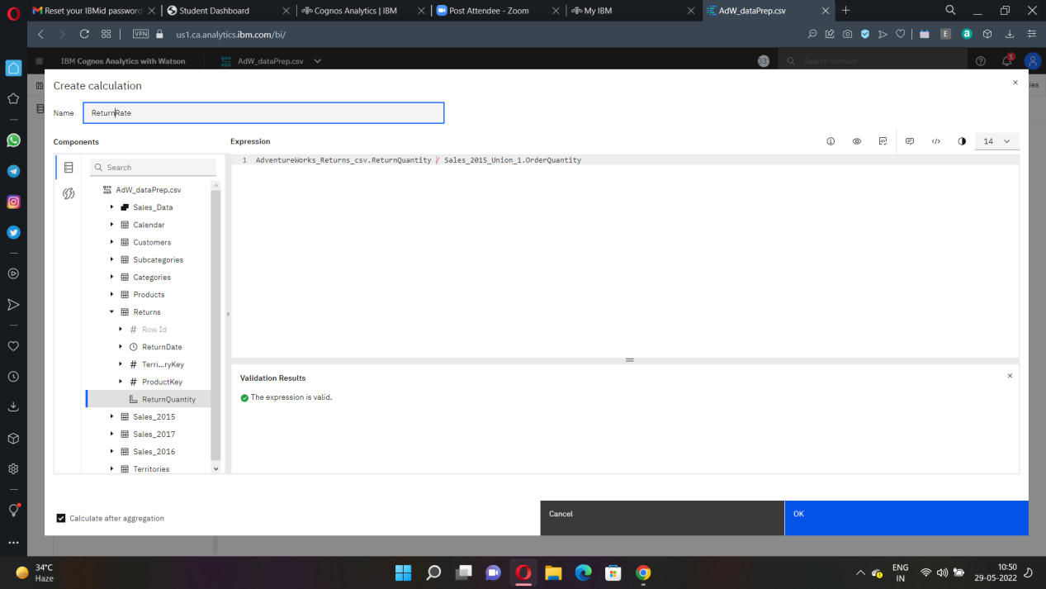

DATA VISUALIZATION:

DASHBOARD:

